*&---------------------------------------------------------------------*  
*& Report  ZYNY_TEST2  
*&  
*&---------------------------------------------------------------------*  
*&  
*&  
*&---------------------------------------------------------------------*  
REPORT ZYNY_TEST2.  
  
DATA LV_CARRID TYPE S_CARR_ID.  
DATA IT_SPFLI TYPE TABLE OF SPFLI. "DECLARE INTERNAL TABLE FOR SPFLI  
SELECT-OPTIONS: S_CARRID FOR LV_CARRID ."  
  
  
START-OF-SELECTION.  
  SELECT * FROM SPFLI INTO TABLE IT_SPFLI  
  WHERE CARRID IN S_CARRID .  
  
*  CALL FUNCTION 'REUSE_ALV_GRID_DISPLAY'  
*   EXPORTING  
*  
*    I_STRUCTURE_NAME                  =  'SPFLI'  
*  
*     I_GRID_TITLE                      = ' GRid display'  
*  
*    TABLES  
*      T_OUTTAB                          = it_spfli  
*   EXCEPTIONS  
*     PROGRAM_ERROR                     = 1  
*     OTHERS                            = 2  
*            .  
*  IF SY-SUBRC <> 0.  
* Implement suitable error handling here  
*  ENDIF.  
  
*---------------------------------------  
  CALL FUNCTION 'REUSE_ALV_LIST_DISPLAY'  
   EXPORTING  
*     I_INTERFACE_CHECK              = ' '  
*     I_BYPASSING_BUFFER             =  
*     I_BUFFER_ACTIVE                = ' '  
*     I_CALLBACK_PROGRAM             = ' '  
*     I_CALLBACK_PF_STATUS_SET       = ' '  
*     I_CALLBACK_USER_COMMAND        = ' '  
     I_STRUCTURE_NAME               = 'SPFLI'  
    TABLES  
      T_OUTTAB                       = IT_SPFLI  
*   EXCEPTIONS  
*     PROGRAM_ERROR                  = 1  
*     OTHERS                         = 2  
            .  
  IF SY-SUBRC <> 0.  
* Implement suitable error handling here  
  ENDIF.

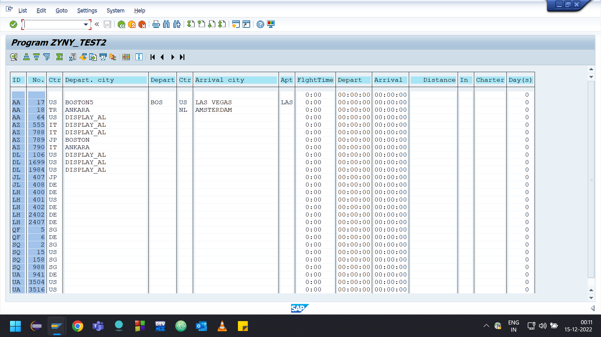

*&---------------------------------------------------------------------*  
*& Report  ZYNY_TEST2  
*&  
*&---------------------------------------------------------------------*  
*&  
*&  
*&---------------------------------------------------------------------*  
REPORT ZYNY_TEST2.  
  
DATA LV_CARRID TYPE S_CARR_ID.  
DATA IT_SPFLI TYPE TABLE OF SPFLI. "DECLARE INTERNAL TABLE FOR SPFLI  
SELECT-OPTIONS: S_CARRID FOR LV_CARRID ."  
  
  
START-OF-SELECTION.  
  SELECT * FROM SPFLI INTO TABLE IT_SPFLI  
  WHERE CARRID IN S_CARRID .  
  
  CALL FUNCTION 'REUSE_ALV_GRID_DISPLAY'  
   EXPORTING  
  
    I_STRUCTURE_NAME                  =  'SPFLI'  
  
     I_GRID_TITLE                      = ' GRid display'  
  
    TABLES  
      T_OUTTAB                          = it_spfli  
   EXCEPTIONS  
     PROGRAM_ERROR                     = 1  
     OTHERS                            = 2  
            .  
  IF SY-SUBRC <> 0.  
* Implement suitable error handling here  
  ENDIF.  
  
*---------------------------------------  
*  CALL FUNCTION 'REUSE_ALV_LIST_DISPLAY'  
*   EXPORTING  
**     I_INTERFACE_CHECK              = ' '  
**     I_BYPASSING_BUFFER             =  
**     I_BUFFER_ACTIVE                = ' '  
**     I_CALLBACK_PROGRAM             = ' '  
**     I_CALLBACK_PF_STATUS_SET       = ' '  
**     I_CALLBACK_USER_COMMAND        = ' '  
*     I_STRUCTURE_NAME               = 'SPFLI'  
*    TABLES  
*      T_OUTTAB                       = IT_SPFLI  
**   EXCEPTIONS  
**     PROGRAM_ERROR                  = 1  
**     OTHERS                         = 2  
*            .  
*  IF SY-SUBRC <> 0.  
** Implement suitable error handling here  
*  ENDIF.

